LINUX PROGRAMMING ASSIGNMENT - 10

NAME - CHARAN P
USN - ENG24CY0091
ROLL.NO - 48
CLASS -CYBERSECURITY
SECTION - “A”

BASIC COMMAND - ‘useradd’
ADVANCED COMMAND - ‘strace -p’

“BASIC COMMAND”

- What is the said commands little history, invention, authors of the command ?
Answer-
The ‘useradd’ command is a low level utility in linux
systems which is used to create new user accounts. It
was originated from early UNIX System V tools, later
incorporated into the Linux Shadow Utilities package
maintained by various open-source contributors. It is
now part of almost all linux distributors.

2. Why the particular command is useful for
System administrator ?
Answer-
- helps create new user accounts efficiently.
- allows configuring user home directory, shell, UID,
GID, expiry date, etc.
- - essential for managing multi-user services.
- - Supports automation for large-scale user
- management.

3. How these said commands are working ?
Answer -
The command updates system files like “ /etc/
passwd, /etc/shadow, and /etc/group to register a
new user.
Example -
Sudo user add -m charan
This creates a new user named “charan” with a home
directory.

4. Few snapshots of the command execution with
proper illustration.
Answer -

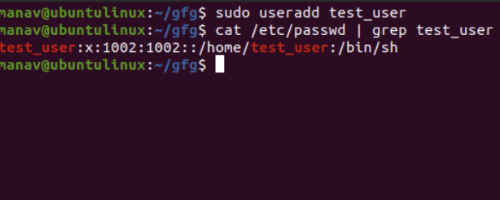
“Since I dint have kali linux I used my friends.”

$ sudo useradd -m testuser
(No output shown - success is silent)
Home directory created at: /home/testuser

5. At least elaborate five to six option and flags
related to the said command. Give sources for
detailed flags and options.
Answer -
- -m : creates home directory
- -d<path> : custom home directory
- -s<shell> : specifies login shell
- -u<UID> : set user ID
- -g<group> : set primary group
- -e<expiry> : set account expiration date

“ADVANCED COMMAND”

1. What is the said commands little history,
invention, authors of the command ?
Answer -
‘strace’ is a powerful diagnostic and debugging
tool used to trace system calls made by a
process. It was developed in early Linux
development era, with contributions from Paul
Kranenburg, Rick Sladkey, and active

maintainers over decades. The ‘-p’ option
attaches trace to an already running process.

2. Why the particular commands are useful for
System administrator ?
Answer -
- helps diagnose why a process is stuck or
misbehaving.
- allows live monitoring of system calls without stopping the process.
- Useful for troubleshooting file access, network issues, or permission errors.

3. How these said commands are working? Give
proper example.
Answer -
It attaches to a running process ID(PID) and prints all
system calls it performs.
Example -
sudo strace -p 1234
This traces system calls of process having PID 1234.

4. Few snapshots of the command execution with
proper illustration.
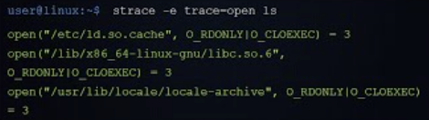
Answer -

open(“/etc/hosts”,O_RDONLY) = 3
read(3,”127.0.0.1 localhost”,128) = 21
close(3) = 0

5. At least elaborate five to six option and flags
related to the said command. Give sources for
detailed flags and options.
Answer -
- -p<pid>: attach to running process
- -o<file>: save output to file
- -f : trace child processes as well
- -e trace=<syscall>: filter specific system calls
- -t : add timestamps
- -v : show detailed output

****THANK YOU****

